1. calculate the Decimal (Dec), the Hexadecimal (Hx), and the Character (Chr) for the following 8-bit number
   1. 0111001
   2. 00101110
   3. 00110101

Decimal

|  |  |  |  |  |  |  |  |
| --- | --- | --- | --- | --- | --- | --- | --- |
| 2^7 | 2^6 | 2^5 | 2^4 | 2^3 | 2^2 | 2^1 | 2^0 |
| 128 | 64 | 32 | 16 | 8 | 4 | 2 | 1 |

Hexadecimal

|  |  |  |  |  |  |  |  |  |  |  |  |  |  |  |  |
| --- | --- | --- | --- | --- | --- | --- | --- | --- | --- | --- | --- | --- | --- | --- | --- |
| 0 | 1 | 2 | 3 | 4 | 5 | 6 | 7 | 8 | 9 | A | B | C | D | E | F |
| 0000 | 0001 | 0010 | 0011 | 0100 | 0101 | 0110 | 0111 | 1000 | 1001 | 1010 | 1011 | 1100 | 1101 | 1110 | 1111 |

a.) 0011-1001

Decimal: 1+8+16+32 = 57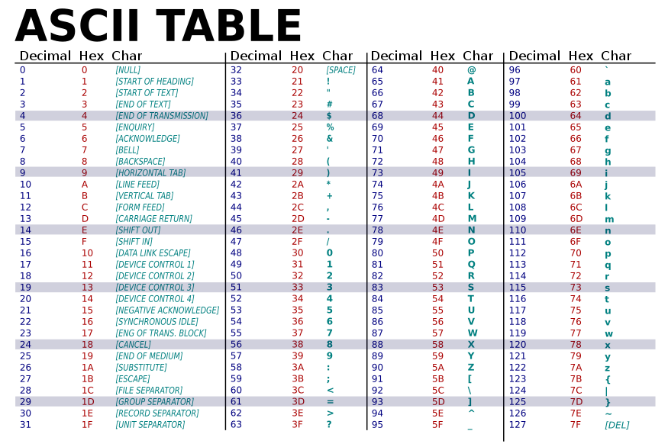

Hexadecimal: 39

Character: 9

b.) 0010-1110

Decimal: 32+8+4+2 = 46

Hexadecimal: 2E

Character: .

c.) 0011-0101

Decimal: 32+16+4+1 = 53

Hexadecimal: 35

Character: 5